**KHULNA UNIVERSITY OF ENGINEERING & TECHNOLOGY**

Department of Electronics & Communication Engineering

**Projecton:**

**Home Automation Using Arduino And IoT Device**

**Course No:**

**ECE-3200**

**Group:**

Progga Labani Howlader(1509035)

Kaniz Tahsin(1509040)

**Objectives:**

The objectives of this project are-

1.To design a home automation using IoT.

2.Using this we can control bulb in our home.

Through this project we can control any device of our home. We can control any home appliance from any where through internet. We also can reduce the power loss problem because sometimes we forget to switch off our home appliance and using this we can switch off these devices. Thus from anywhere we can control our home appliances. Saving electricity means decreasing the amount of current. Using less current we can save money and environment. Because generating energy requires precious natural resources. If we require less amount of current or decrease the loss of current ,so we will burn less amount of natural resources. Thus we can save electricity and also protect our environment from pollution.

In future we will try to control more than one home appliance. We will also try to use this in other fields.

**Introduction:**

In this project showing how we can control our home appliances from anywhere in world using Internet. In our daily life we always forget to switch off Lights, TV, AC, Fan and other appliances and unnecessary we waste electricity and money of course, which is very precious for us.

In our busy life we always face the power loss problem. Thus it hampers the progress of our country. So we should reduce this problem. Our project will help us to reduce this problem. In this project the user can see the present condition of the home appliances through a website. And the user will take the necessary step that he wants. Thus he can save his time and can reduce the power loss problem.

Here in this project we will use a node mcu developer board which will connect the website and we can control the home appliance. Mainly the developer board will connect with the device and it will control them. Using it, every person can save their money. Reducing the waste of electricity means reducing the waste of money. Thus we not only help ourselves, we also help the economy of our country. In this way we can contribute to the progress of our nation.

**Block diagram:**

**NODE MCU developer board**

**Power Supply**

**Relay 1**

**Bulb 1**

**Arduino UNO**

**Figure**: Block diagram of home automation Using Node MCU developer board and arduino.

**Circuit Diagram:**

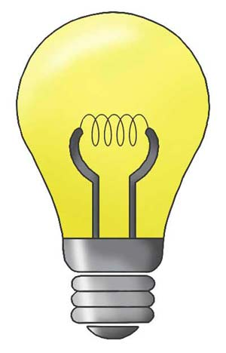

**AC**

**supply**

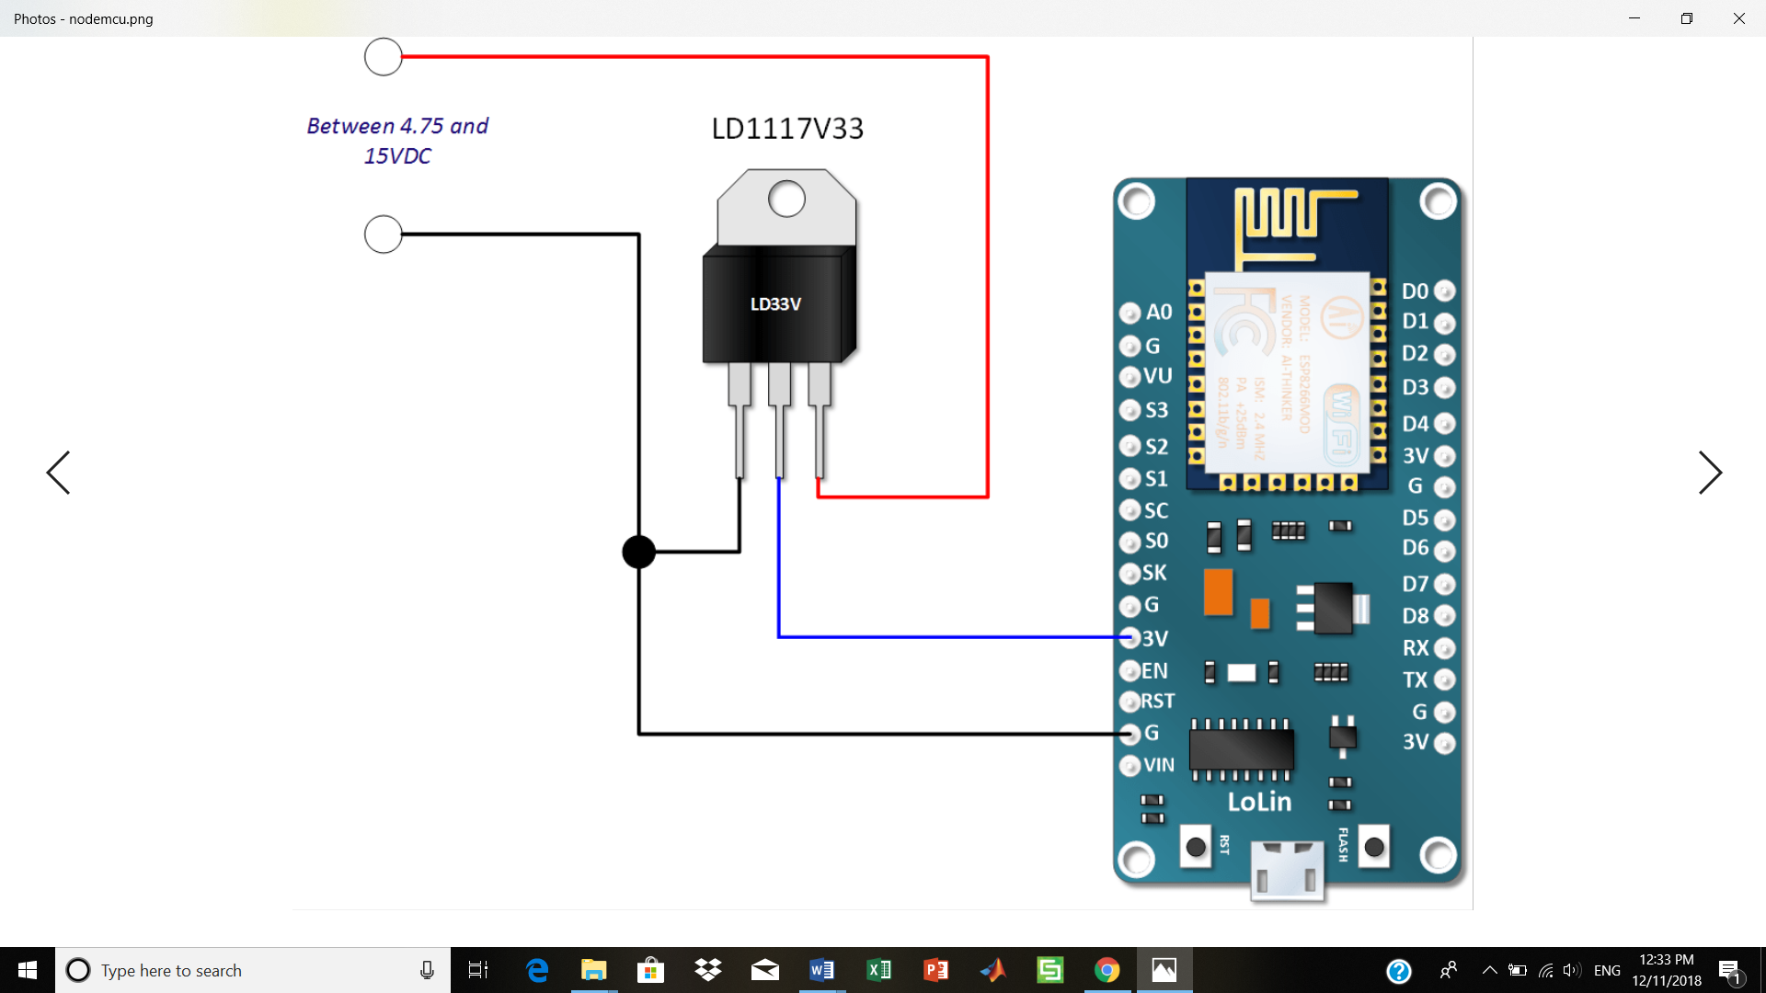 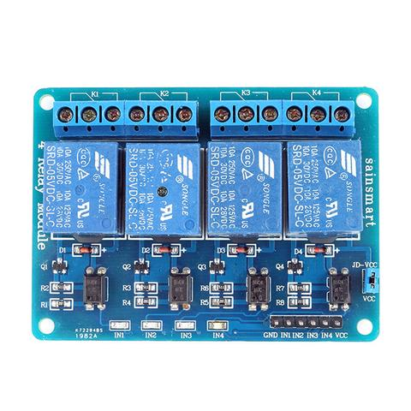

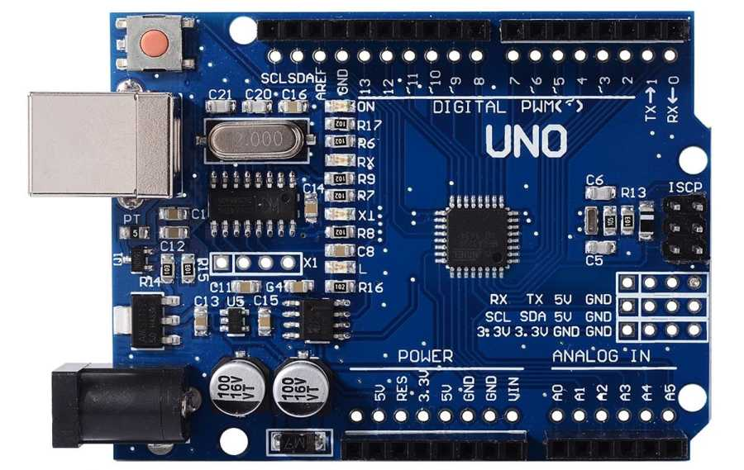

**Figure:** Circuit diagram of home automation Using Node MCU developer board and arduino.

**Working Principle:**

In this project we used node mcu developer board in which we uploaded the code. The D0 pin of the board was connected to the IN2 port of the relay board through which the code was given to work in the relay board. The one ground pin of the developer board was connected to the ground pin of the relay board. The relay board needed 5V vcc. So we used arduino uno to supply 5V to the vcc pin of the relay board. The other ground pin of the developer board was connected to the ground pin of the arduino uno. We connected AC devices to the output terminals of the relay. First we connected one wire (Phase) of the AC source with the common terminal (COM) of all relays and the second wire (Neutral) of AC source to one terminal of AC devices. Then we connected the other terminal of AC devices to the NO (Normally Open) terminal of relays.

**Analysis:**

In this experiment we connected the node mcu developer board with the relay board. Here we used the connect as the circuit diagram. The developer board is used to control the bulb and to connect with the wifi network. We created an account in the web server ubidots. From this website we controlled the bulb. In this site we created a switch which will show the condition of our home appliance. And through the site using the code we can connect with the wifi network and can control the bulb. When we pressed 1 in the site the bulb turned on and when we pressed 0 in the site the bulb turned off. Thus we can easily control our home appliance through our website from anywhere in the world.

**Discussion:**

In this project we familiarized with the IoT based home automation control system. Here first we faced some problems when used esp8266 wifi module. We could not connect the module with the wifi network. Then we used node mcu developer board to connect with the wifi. And we successfully able to connect with the wifi. Here we would be able to control our home devices through the internet. There is a website where we will see the current conditions of our home devices. In this website there we created the on/off option and user will control these devices only by a click. Thus from anywhere in the world a user will be able to control his home appliances. Now we can control one bulb through our own website successfully.

**Conclusion:**

From this report we learnt the basic concept of control home appliances using IoT. After completing this project we able to control one bulb at our home from anywhere. In future we will be able to control more than one devices. We will work on it in future to add more features. In our project we now control one bulb only. But in future we will be able to control many devices not only bulb. Thus we will be able to control any devices of our home through internet from anywhere in the world. And we think we will also can change the function of the devices through the internet. Thus we can easily control our home.

**Code:**

#include "UbidotsMicroESP8266.h"

#define DEVICE "control" // Put here your Ubidots device label

#define VARIABLE "led" // Put here your Ubidots variable label

#define TOKEN "A1E-P5i8v1MrFcrxCmms1LKXLIIQlEjqXf" // Put here your Ubidots TOKEN

#define WIFISSID "progga" // Put here your Wi-Fi SSID

#define PASSWORD "progga30" // Put here your Wi-Fi password

Ubidots client(TOKEN);

void setup() {

Serial.begin(115200);

client.wifiConnection(WIFISSID, PASSWORD);

pinMode(D0, OUTPUT);

//client.setDebug(true); // Uncomment this line to set DEBUG on

}

void loop() {

float value = client.getValueWithDevice(DEVICE, VARIABLE);

if (value == 1){

Serial.print(F("value obtained: "));

Serial.println(value);

digitalWrite(D0, LOW);

}else{

Serial.print(F("value obtained: "));

Serial.println(value);

digitalWrite(D0, HIGH);

}

delay(1000);

}

**Reference:**

1.<https://www.hackster.io/iotboys/control-home-appliance-from-internet-using-arduino-and-wifi-f65e10>

2. <http://iotboys.com/how-to-control-home-appliances-from-internet-using-arduino-and-esp8266/>

3. <https://create.arduino.cc/projecthub/iotboys/control-home-appliance-from-internet-using-arduino-and-wifi-f65e10>

4.<https://www.google.com/search?q=block+diagram+of+control+home+appliance+using+arduino+and+wifi&tbm=isch&tbo=u&source=univ&sa=X&ved=2ahUKEwi3y_av9vndAhWCqo8KHbFwD-QQsAR6BAgGEAE#imgrc=j78jcinlnPkY0M>: